Final Project

Economics 5495-001: R-Programming

P. Christopher J. Daigle

1 May 2018

University of Connecticut

Prof. Min Seong Kim

Table of Contents

1 Project Overview 3

2 Data: Setting Up 3

3 Data: Summary 4

4 Data: Sub-setting 5

5 Simple Analysis 6

6 Conclusion 7

A. Appendix: Programing and Output 8

# **1 Project Overview**

The data analyzed in my project relates to the results of the Idaho Standards Achievement Test (ISAT) over the period 2007 to 2013 and measures of school spending. The data is of original construction by me and is sourced from the Idaho State Department of Education (IDSDE), the Bureau of Labor Statistics (BLS), and Idaho Voices for Children (IVC).

The period of interest was chosen based on two criteria. First, 2007 marked the beginning of a major financial crisis that affected not only results in the market for housing, equities, and employment, but also government allocations to education. Idaho experienced a decrease in state funding for K-12 education by 17.14%, the fourth largest decrease in the nation. The second criteria for this time frame is related to the integrity of measurement. In 2014, the ISAT was not administered and was instead completely modified to measure totally different outcomes. In 2015, this new version of the ISAT was administered. Thus, using the results from this exam would be like measuring weight in feet and length in pounds; it would be meaningless.

# **2 Data: Setting Up**

To import the data, I begin with it set as a data table, not data frame, for speed of import based on the size. After importing the data, renaming, and converting to a data frame, it is clear much cleaning is necessary.

The names of the variables contain spaces. So, to adhere to conventions in R, I have written a function to remove the spaces and replace them with periods. As the school districts are numerical and are categorical in nature, I changed these to a class of factors. The time variable is in years but seen as a character and not in a format R recognizes as a date. To account for this, I added a string to the observations and converted them from character to date class.

From there, I noted many variables which should be numerical are of character class. To account for this, I have written a loop to re-class each of these variables to numeric, so they may be operated upon. I then begin a summary analysis of key items

# **3 Data: Summary**

Upon import, the data begins with 116 variables spanning 27,777 observations. It includes scores from the ISAT in Language Usage, Mathematics, Reading, and Science. I start by observing the distribution of all districts with their proportion of students passing all subjects:



The mean is around 41.44% with a median around 42%.

To observe the proportion of students who passed the exam, by each subject, a boxplot is used:



The subject students performed best, on average, is Language Usage and they performed worst on Science. The mean of the proportion of students passing Language Usage is 43.59% with a maximum of 100%. The mean of Mathematics is 39.91% with a maximum of 90.9%. The mean of Reading is 43.78 with a maximum of 92.3%. The mean of Science is 33.38% with a maximum of 84.6%

To see the distribution of districts and their proportions of passing the ISAT, histograms of each subject are created and show Reading and Mathematics have about the same proportion of students passing, by district. Language Usage, as before, shows the most districts with greater than 50% passing and Science shows the fewest.



# **4 Data: Sub-setting**

From here, I employed numerous loops to subset the data on different conditions. First, I subset conditional on Year resulting in 7 relevant data frames subset from the original. Next, I subset on Subject resulting in 4 relevant data frames. Then, I subset on Year and Subject resulting in 28 relevant data frames. Finally, I subset for a totally balanced data set (i.e. no missing observations) for a single year (2013), single subject (Mathematics), which resulted in a paring down from 27,777 observations to 884. When accounting for outliers, the number of observations decreased to 876.

# **5 Simple Analysis**

As math scores have been shown to reveal economically and statistically meaningful results, I decided to analyze the data related to math. To see how the proportion of students passing math changed year-over-year, I used a boxplot for each time frame:



We can see an increase in the range and slight changes to the mean.

Next, I performed a regression on the proportion of students passing math in the 6th grade on real per-pupil-expenditure:



I began with all of the data, followed by removing the outliers, and then logarithmically transformed the data. Then, I subset for just the 6th grade and regressed as previously done:



The results from each, regardless of subset, are similar.

# **6 Conclusion**

The key takeaways from observing this data are the necessity of cleaning and using different conditions to subset for reasonable analysis. When I account for the level of imbalance, the data becomes noticeably smaller.

Generally, Idaho School Districts perform best on Language Usage, worst on Science, and about the same between Reading and Mathematics. In each subject, the mean proportion of students passing is grouped around 33% - 43%. There are likely issues with homoskedasticity as seen from the scatter plots of the regression analysis for which should be controlled to make reasonable statistical inference. Simply observing the direction of the fitted lines in the different three-paneled figures reveals issues with inference using only simple OLS.

# **A. Appendix: Programing and Output**

# Chris Daigle  
# Econ5495 - R Programming  
# Class Project  
#  
rm(list = ls())  
#  
# Employing packages ####  
#  
library('dplyr')

library('tidyr')

library('car')

library('data.table')

library('plm')

# Importing ####  
#  
setwd(  
 '/Users/daiglechris/Library/Mobile Documents/com~apple~CloudDocs/Education/UConn/Spring 2018/R/Project'  
)  
# setwd(  
# '/Users/2011home/Library/Mobile Documents/com~apple~CloudDocs/Education/UConn/Spring 2018/R/Project'  
# )  
  
IDSAT <-  
 fread('ISAT District Master 23Mar2016.csv', stringsAsFactors = FALSE  
 )  
  
# Renaming ####  
#  
names(IDSAT)[names(IDSAT) == 'Dist #'] <- 'Dist'  
names(IDSAT)[names(IDSAT) == 'Admin ID'] <- 'AdID'  
names(IDSAT)[names(IDSAT) == 'Year'] <- 'Yr'  
names(IDSAT)[names(IDSAT) == 'grade'] <- 'Grade'  
names(IDSAT)[names(IDSAT) == 'Annual Expenditure'] <- 'AnnExp'  
names(IDSAT)[names(IDSAT) == 'Taxes'] <- 'Tax'  
names(IDSAT)[names(IDSAT) == 'Other Local Sources'] <- 'OthLcl'  
names(IDSAT)[names(IDSAT) == 'State Sources'] <- 'State'  
names(IDSAT)[names(IDSAT) == 'Federal Sources'] <- 'Fed'  
names(IDSAT)[names(IDSAT) == 'Other Sources'] <- 'OthLcl'  
names(IDSAT)[names(IDSAT) == 'Membership'] <- 'Mem'  
names(IDSAT)[names(IDSAT) == 'TotalPerPupilExpenditure'] <- 'TotPPE'  
names(IDSAT)[names(IDSAT) == '4DAY WEEKS'] <- 'Day'  
names(IDSAT)[names(IDSAT) == 'FRLNumber'] <- 'FRL'  
names(IDSAT)[names(IDSAT) == 'EstimatedTotalPopulation(OfTheSchoolDistrict)'] <-  
 'PopEstDist'  
names(IDSAT)[names(IDSAT) == 'EstimatedPopulation517(ChildrenInSchool)'] <-  
 'Pop517EstDist'  
names(IDSAT)[names(IDSAT) == 'PovEstimatedNumberOfRelevantChildren5To17YearsOldInPovertyWhoAreRelatedToTheHouseholder(NumberOfChildrenInPoverty)'] <-  
 'Pov'  
names(IDSAT)[names(IDSAT) == 'FY Inflation (Index)'] <- 'InfInd13'  
names(IDSAT)[names(IDSAT) == 'Annual Expenditure Adjusted for Inflation (2013)'] <-  
 'AnnInfExp'  
names(IDSAT)[names(IDSAT) == 'Total PPE Adjusted for Inflation'] <-  
 'InfPPE'  
IDSAT <- as.data.frame(IDSAT)  
# write a function to replace the spaces data.table induced to keep in line with  
# the data.frame/base-r syntax  
  
spaceless <- function(x) {  
 colnames(x) <- gsub(" ", ".", colnames(x))  
 x  
}  
IDSAT <- spaceless(IDSAT)  
  
# Assign proper classes to variables ####  
#  
for (i in c(1:2)) {  
 IDSAT[, i] <- as.character(IDSAT[, i])  
}  
  
IDSAT$Dist <- factor(IDSAT$Dist, ordered = FALSE)  
IDSAT$Yr <- as.Date(paste0(IDSAT$Yr, '-01-01'))

## Warning in strptime(xx, f <- "%Y-%m-%d", tz = "GMT"): unknown timezone  
## 'zone/tz/2018c.1.0/zoneinfo/America/New_York'

IDSAT$Grade <- as.numeric(as.character(IDSAT$Grade))  
# IDSAT <- IDSAT[order(IDSAT$Grade), ]  
# IDSAT$Grade <- factor(IDSAT$Grade)  
  
for (i in c(97:112)) {  
 IDSAT[, i] <- as.numeric(as.character(IDSAT[, i]))  
}

# Make dummies ####  
#  
IDSAT$int0 <- 0  
for (i in c(3:9)) {  
 for (j in unique(IDSAT$Yr)){  
 IDSAT$int0[IDSAT$Grade == i & IDSAT$Yr == j] <- 1  
 }  
}  
#  
IDSAT$int1 <- 0  
for (i in c(4:10)) {  
 for (j in unique(IDSAT$Yr)){  
 IDSAT$int1[IDSAT$Grade == i & IDSAT$Yr == j] <- 1  
 }  
}  
IDSAT$int2 <- 0  
for (i in c(5:11)) {  
 for (j in unique(IDSAT$Yr)){  
 IDSAT$int2[IDSAT$Grade == i & IDSAT$Yr == j] <- 1  
 }  
}  
#  
IDSAT$int3 <- 0  
for (i in c(6:12)) {  
 for (j in unique(IDSAT$Yr)){  
 IDSAT$int3[IDSAT$Grade == i & IDSAT$Yr == j] <- 1  
 }  
}  
  
# Subsetting for Years and Subjects####  
  
# Create a vector of list of names to use for assignment  
IDSATYears <- 0  
for (i in c(7:13)) {  
 IDSATYears[i - 6] <- paste('IDSAT', i, sep = '')  
}  
# Create a vector of list of names to use for assignment  
YearNames <- 0  
for (i in c(2007:2013)) {  
 YearNames[i - 2006] <- paste0(i, '-01-01')  
}  
# Subset by years  
for (i in c(1:length(unique(IDSAT$Yr)))) {  
 assign(IDSATYears[i], IDSAT[IDSAT$Yr == unique(IDSAT$Yr)[i], ])  
}  
# Subset by subject  
for (i in c(1:length(unique(IDSAT$Subject)))) {  
 nam <- paste('IDSAT', unique(IDSAT$Subject)[i], sep = ".")  
 assign(nam, IDSAT[IDSAT$Subject == unique(IDSAT$Subject)[i], ])  
}  
# Subset each subject by year  
for (j in c(1:length(IDSATYears))) {  
 for (i in c(1:4)) {  
 nam <- paste(IDSATYears[j], unique(IDSAT$Subject)[i], sep = ".")  
 assign(nam, IDSAT[IDSAT$Subject == unique(IDSAT$Subject)[i] &  
 IDSAT$Yr == YearNames[j], ])  
 }  
}  
# Remove all NA values on the endogenous variable measuring pass rate  
balanced13 <- subset(IDSAT13, (!is.na(IDSAT13$All.P)))  
  
# Plots ####  
#  
# Histograms of percent of students passing for all years and then by subjects  
# for all years  
#  
colorsV <-  
 c(  
 rgb(1, 0, 0, 0.2),  
 rgb(0, 1, 0, 0.2),  
 rgb(0, 0, 1, 0.2),  
 rgb(0, 0, 0.5, 0.2),  
 rgb(0.5, 0, 0.5, 0.2),  
 rgb(0.5, 0.5,0, 0.2)  
 )  
require(ggplot2)

## Loading required package: ggplot2

IDSATm <- melt(IDSAT, id.var = 'Subject')

#  
ggplot(data = IDSAT, aes(x = IDSAT$Subject, y = IDSAT$All.P)) + geom_boxplot(aes(fill = Subject)) + labs(x = 'Subjects', y = 'Percent of Students Passsing') + scale_fill_manual(values = c(colorsV[3], colorsV[2], colorsV[1], colorsV[4]))

## Warning: Removed 5097 rows containing non-finite values (stat_boxplot).

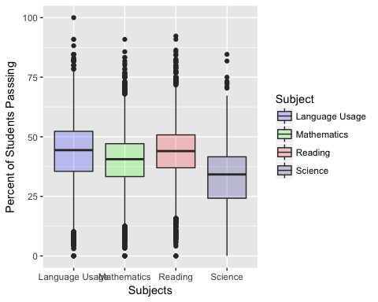

#  
par(mfrow = c(1, 1))  
boxplot(IDSAT.Reading$All.P ~ IDSAT.Reading$Yr, ylab = 'Percent of Students Passing', xlab = 'Year', main = 'Percent of Students Passing Reading by Year', col = colorsV[1])

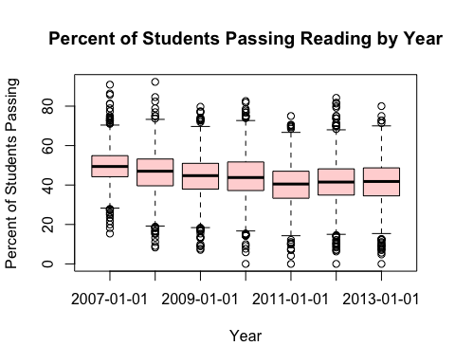

#  
boxplot(IDSAT.Mathematics$All.P ~ IDSAT.Mathematics$Yr, ylab = 'Percent of Students Passing', xlab = 'Year', main = 'Percent of Students Passing Math by Year', col = colorsV[2])

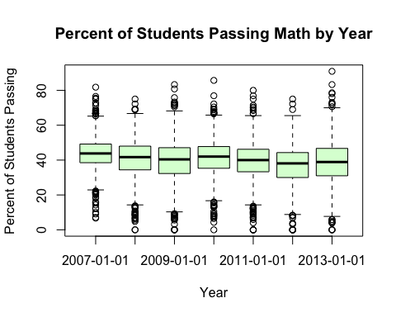

#  
boxplot(`IDSAT.Language Usage`$All.P ~ `IDSAT.Language Usage`$Yr, ylab = 'Percent of Students Passing', xlab = 'Year', main = 'Percent of Students Passing Language Usage by Year', col = colorsV[3])

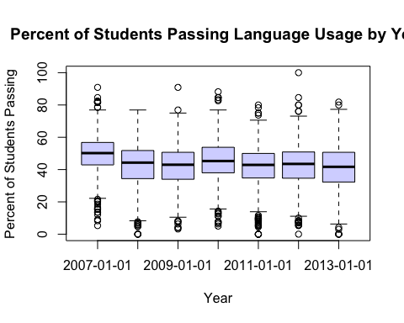

#  
boxplot(IDSAT.Science$All.P ~ IDSAT.Science$Yr, ylab = 'Percent of Students Passing', xlab = 'Year', main = 'Percent of Students Passing Science by Year', col = colorsV[4])

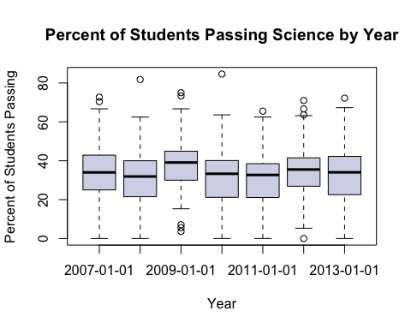

#  
# All Passing  
hist(  
 IDSAT$All.P,  
 xlab = '% of Students Passing All Subjects',  
 ylab = 'No. of Districts',  
 ylim = c(0, 4750) ,  
 main = '% of Students Passing by No. of Districts',  
 col = colorsV[5]  
)

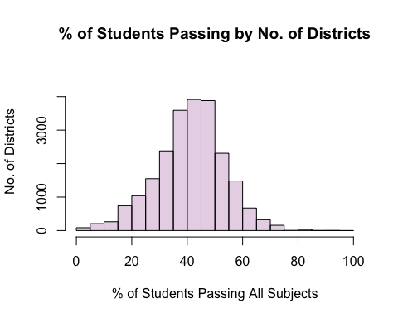

mean(IDSAT$All.P, na.rm = TRUE)

## [1] 41.43562

median(IDSAT$All.P, na.rm = TRUE)

## [1] 42

#  
par(mfrow = c(2, 2))  
for (j in c(1:4)) {  
 hist(  
 IDSAT$All.P[IDSAT$Subject == unique(IDSAT$Subject)[j]],  
 xlab = paste('% Pass', unique(IDSAT13$Subject)[j]),  
 ylab = 'Number of Districts',  
 main = '% Pass by No. of Districts',  
 col = colorsV[j]  
 )  
}

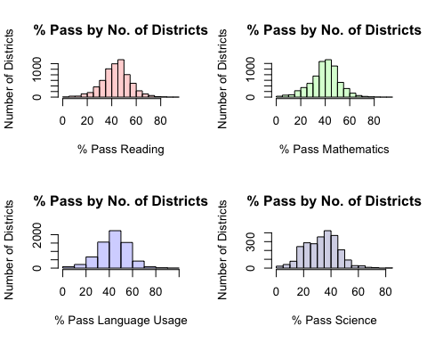

mean(IDSAT$All.P[IDSAT$Subject == "Language Usage"], na.rm = TRUE)

## [1] 43.59049

max(IDSAT$All.P[IDSAT$Subject == "Language Usage"], na.rm = TRUE)

## [1] 100

mean(IDSAT$All.P[IDSAT$Subject == "Mathematics"], na.rm = TRUE)

## [1] 39.90792

max(IDSAT$All.P[IDSAT$Subject == "Mathematics"], na.rm = TRUE)

## [1] 90.9

mean(IDSAT$All.P[IDSAT$Subject == "Reading"], na.rm = TRUE)

## [1] 43.78376

max(IDSAT$All.P[IDSAT$Subject == "Reading"], na.rm = TRUE)

## [1] 92.3

mean(IDSAT$All.P[IDSAT$Subject == "Science"], na.rm = TRUE)

## [1] 33.37944

max(IDSAT$All.P[IDSAT$Subject == "Science"], na.rm = TRUE)

## [1] 84.6

# Reading  
par(mfrow = c(2, 4))  
hist(  
 IDSAT$All.P[IDSAT$Subject == unique(IDSAT$Subject)[1]],  
 xlab = paste('% Pass', unique(IDSAT13$Subject)[1]),  
 ylab = 'Number of Districts' ,  
 main = '% Pass by No. of Districts',  
 col = colorsV[1]  
)  
for (i in c(1:length(IDSATYears))) {  
 hist(  
 IDSAT$All.P[IDSAT$Subject == unique(IDSAT$Subject)[1] &  
 IDSAT$Yr == unique(IDSAT$Yr)[i]],  
 xlab = paste('% Pass', unique(IDSAT13$Subject)[1]),  
 ylab = 'Number of Districts' ,  
 main = unique(IDSAT$Yr)[i],  
 col = colorsV[1]  
 )  
}

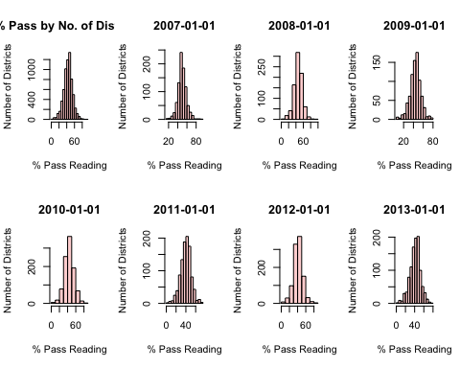

# Math  
hist(  
 IDSAT$All.P[IDSAT$Subject == unique(IDSAT$Subject)[2]],  
 xlab = paste('% Pass', unique(IDSAT13$Subject)[2]),  
 ylab = 'Number of Districts' ,  
 main = '% Pass by No. of Districts',  
 col = colorsV[2]  
)  
for (i in c(1:length(IDSATYears))) {  
 hist(  
 IDSAT$All.P[IDSAT$Subject == unique(IDSAT$Subject)[2] &  
 IDSAT$Yr == unique(IDSAT$Yr)[i]],  
 xlab = paste('% Pass', unique(IDSAT13$Subject)[2]),  
 ylab = 'Number of Districts' ,  
 main = unique(IDSAT$Yr)[i],  
 col = colorsV[2]  
 )  
}

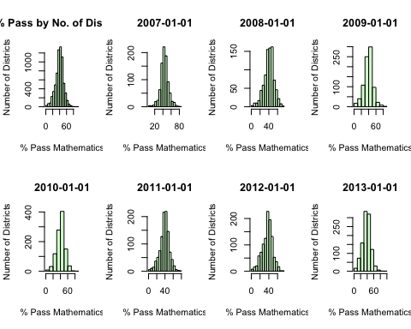

# Language Usage  
hist(  
 IDSAT$All.P[IDSAT$Subject == unique(IDSAT$Subject)[3]],  
 xlab = paste('% Pass', unique(IDSAT13$Subject)[3]),  
 ylab = 'Number of Districts' ,  
 main = '% Pass by No. of Districts',  
 col = colorsV[3]  
)  
for (i in c(1:length(IDSATYears))) {  
 hist(  
 IDSAT$All.P[IDSAT$Subject == unique(IDSAT$Subject)[3] &  
 IDSAT$Yr == unique(IDSAT$Yr)[i]],  
 xlab = paste('% Pass', unique(IDSAT13$Subject)[3]),  
 ylab = 'Number of Districts' ,  
 main = unique(IDSAT$Yr)[i],  
 col = colorsV[3]  
 )  
}

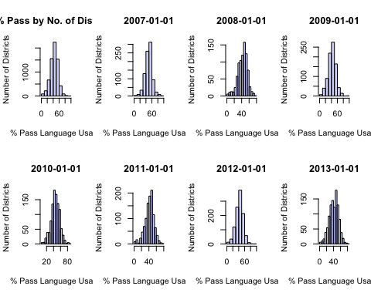

#  
hist(  
 IDSAT$All.P[IDSAT$Subject == unique(IDSAT$Subject)[4]],  
 xlab = paste('% of Students Passing', unique(IDSAT13$Subject)[4]),  
 ylab = 'Number of Districts' ,  
 main = '% Passing by No. of Districts',  
 col = colorsV[4]  
)  
for (i in c(1:length(IDSATYears))) {  
 hist(  
 IDSAT$All.P[IDSAT$Subject == unique(IDSAT$Subject)[4] &  
 IDSAT$Yr == unique(IDSAT$Yr)[i]],  
 xlab = paste('% of Students Passing', unique(IDSAT13$Subject)[4]),  
 ylab = 'Number of Districts' ,  
 main = unique(IDSAT$Yr)[i],  
 col = colorsV[4]  
 )  
}

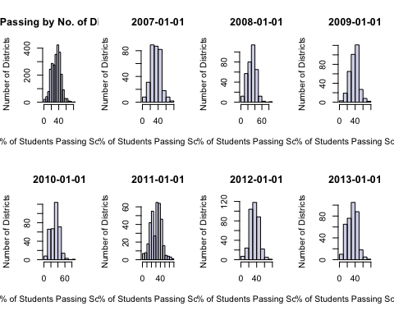

#  
summary(balanced13$TotPPE)

## Min. 1st Qu. Median Mean 3rd Qu. Max. NA's   
## 4336 7368 8787 9740 11229 39939 3

quantile(IDSAT$TotPPE, na.rm = TRUE)

## 0% 25% 50% 75% 100%   
## 3795.79 7763.63 9341.45 12112.36 83955.56

anova(lm(IDSAT$All.P ~ IDSAT$Dist))

## Analysis of Variance Table  
##   
## Response: IDSAT$All.P  
## Df Sum Sq Mean Sq F value Pr(>F)   
## IDSAT$Dist 151 367257 2432.16 17.327 < 2.2e-16 ***  
## Residuals 22528 3162294 140.37   
## ---  
## Signif. codes: 0 '***' 0.001 '**' 0.01 '*' 0.05 '.' 0.1 ' ' 1

reg1 <- lm(All.P ~ Mem + FRL + Day, data = IDSAT)  
  
# Graphics ####  
par(mfrow = c(1,1))  
plot(  
 All.P ~ InfPPE,  
 data = IDSAT,  
 xlab = 'Per Pupil Expenditure in Dollars ($)',  
 ylab = 'Proportion of Students who Passed',  
 main = 'Proportion of Students who Passed the ISAT by Spending'  
)

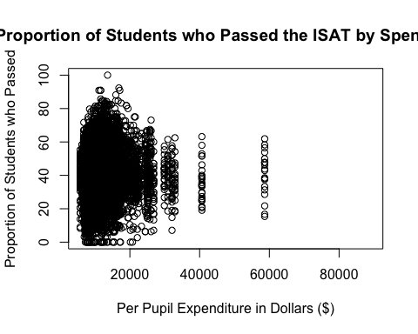

#  
hist(IDSAT.Mathematics$InfPPE, col = colorsV[5], freq = FALSE)

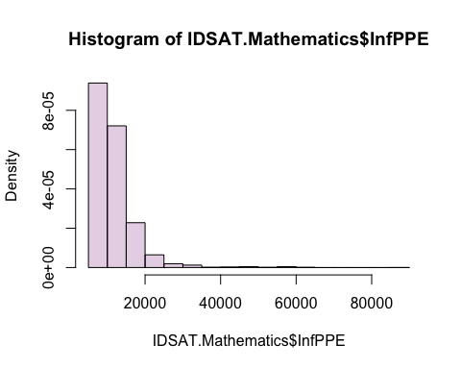

#  
attach(IDSAT13.Mathematics)  
plot(  
 All.P[Grade == 6] ~ InfPPE[Grade == 6],  
 pch = 20,  
 col = colorsV[3],  
 xlab = 'FY13 Inflated Per-Pupil, Grade 6, Expenditure',  
 ylab = '% Passing Mathematics, Grade 6',  
 main = 'Percent of Students Passing Math in the 6th Grade\n by the Amount of Real-Per-Pupil Funding'  
)  
reg1 <-  
 lm(All.P[Grade == 6] ~ InfPPE[Grade == 6])  
abline(reg1, col = 'red', lwd = 3)

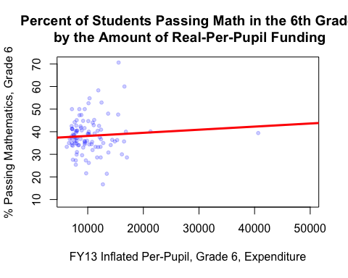

reg1

##   
## Call:  
## lm(formula = All.P[Grade == 6] ~ InfPPE[Grade == 6])  
##   
## Coefficients:  
## (Intercept) InfPPE[Grade == 6]   
## 3.676e+01 1.377e-04

# Balance and identify the outlier  
balanced13M <- IDSAT13.Mathematics[!(is.na(IDSAT13.Mathematics$All.P) | is.na(IDSAT13.Mathematics$InfPPE)), ]  
spendOutlier <- max(balanced13M$InfPPE)  
spendOutlier

## [1] 40649.87

detach()  
b13MNoOut <- balanced13M[!(balanced13M$InfPPE == spendOutlier),]  
attach(b13MNoOut)  
spendOutlier <- max(InfPPE)  
#  
plot(  
 All.P[Grade == 6] ~ InfPPE[Grade == 6],  
 pch = 20,  
 col = colorsV[3],  
 xlab = 'FY13 Inflated Per-Pupil, Grade 6, Expenditure',  
 ylab = '% Passing Mathematics, Grade 6',  
 main = 'Percent of Students Passing Math in the 6th Grade\n by the Amount of Real-Per-Pupil Funding'  
)  
reg2 <-  
 lm(All.P[Grade == 6] ~ InfPPE[Grade == 6])  
reg2

##   
## Call:  
## lm(formula = All.P[Grade == 6] ~ InfPPE[Grade == 6])  
##   
## Coefficients:  
## (Intercept) InfPPE[Grade == 6]   
## 3.572e+01 2.429e-04

abline(reg2, col = 'red', lwd = 3)

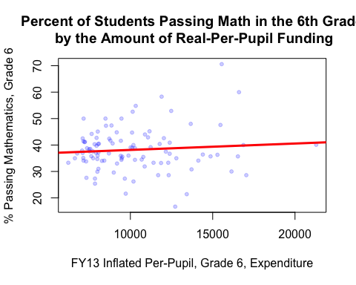

#  
lInfPPE <- log(InfPPE[Grade == 6])  
lAll.P <- log(All.P[Grade == 6])  
plot(  
 lAll.P[Grade == 6] ~ lInfPPE[Grade == 6],  
 pch = 20,  
 col = colorsV[3],  
 xlab = 'Log ofFY13 Inflated Per-Pupil, Grade 6, Expenditure',  
 ylab = '% Passing Mathematics, Grade 6',  
 main = 'Percent of Students Passing Math in the 6th Grade\n by the Log of Real-Per-Pupil Funding'  
)  
reg3 <-  
 lm(lAll.P[Grade == 6] ~ lInfPPE[Grade == 6])  
reg3

##   
## Call:  
## lm(formula = lAll.P[Grade == 6] ~ lInfPPE[Grade == 6])  
##   
## Coefficients:  
## (Intercept) lInfPPE[Grade == 6]   
## 5.6818 -0.2387

abline(reg3, col = 'red', lwd = 3)

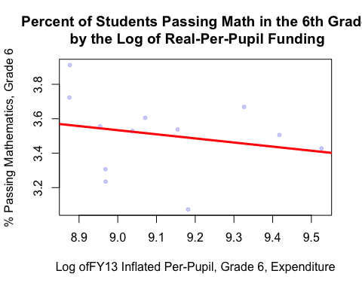

#  
#  
detach()  
attach(IDSAT13.Mathematics)  
par(mfrow = c(1,3))  
plot(  
 All.P[Grade == 6] ~ InfPPE[Grade == 6],  
 pch = 20,  
 col = colorsV[3],  
 xlab = 'Real PPE, Grade 6',  
 ylab = '% Passing Mathematics, Grade 6',  
 main = 'Linear'  
)  
abline(reg1, col = 'red', lwd = 3)  
  
detach()  
attach(b13MNoOut)  
plot(  
 All.P[Grade == 6] ~ InfPPE[Grade == 6],  
 pch = 20,  
 col = colorsV[3],  
 xlab = 'Real PPE, Grade 6',  
 ylab = '% Passing Mathematics, Grade 6',  
 main = 'No Outlier'  
)  
abline(reg2, col = 'red', lwd = 3)  
  
lInfPPE <- log(InfPPE[Grade == 6])  
lAll.P <- log(All.P[Grade == 6])  
plot(  
 lAll.P[Grade == 6] ~ lInfPPE[Grade == 6],  
 pch = 20,  
 col = colorsV[3],  
 xlab = 'Log Real PPE',  
 ylab = 'Log % Passing Mathematics, Grade 6',  
 main = 'Logarithmic'  
)  
abline(reg3, col = 'red', lwd = 3)

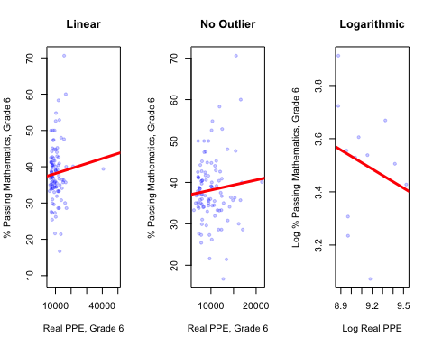

#  
# Variable Meanings ####  
#  
# Definition: Dist "District number"  
#  
# Definition: Yr "Year of observation (2007-2013)"  
#  
# Definition: Grade "Grade of tested students in a district (3-12)"  
#  
# Definition: AnnExp "Total annual expenditure in a district for a particular  
# year"  
#  
# Definition: Tax "Total amount of tax revenue in a district for a particular  
# year"  
#  
# Definition: OthLcl "Total amount of revenue from local sources not contained  
# in other revenue streams"  
#  
# Definition: State "Total amount of revenue from state sources"  
#  
# Definition: Fed "Total amount of revenue from federal sources"  
#  
# Definition: Oth "Total amount of revenue from sources not contained in any  
# other revenue stream"  
#  
# Definition: Mem "Total number of students in a district on a particular day"  
#  
# Definition: TotPPE "Total per-pupil-expenditure by district"  
#  
# Definition: Day "Binary variable indicating if a school district has 4-day  
# school weeks"  
#  
# Definition: FRL "Total number of students in a district receiving free or  
# reduced lunch"  
#  
# Definition: PopEstDist "Estimate from US Census of the population in a  
# district"  
#  
# Definition: Pop517EstDist "Estimate from US Census of the population aged 5 to  
# 17 years in a district"  
#  
# Definition: Pov "Estimate from US Census of the population aged 5 to 17 years  
# living in poverty in a district"  
#  
# Definition: InfInd13 "Index for Inflation in a fiscal year with fiscal year  
# 2013 as the base year (Jul-Jun)"  
#  
# Definition: AnnInfExp "Annual expenditure Inflated to 2013 dollars"  
#  
# Definition: InfPPE "Per-pupil-expenditure Inflated to 2013 dollars"  
#  
# Definition: allss "Average scaled score for all tested"  
#  
# Definition: allbb "Percent of below basic for all tested"  
#  
# Definition: allb "Percent of basic for all tested"  
#  
# Definition: allp "Percent of proficient for all tested"  
#  
# Definition: alla "Percent of advanced for all tested"  
#  
# Definition: maless "Average scaled score for all Males tested"  
#  
# Definition: maletested "Number of Males tested"  
#  
# Definition: malebb "Percent of below basic for Males tested"  
#  
# Definition: maleb "Percent of basic for Males tested"  
#  
# Definition: malep "Percent of proficient for Males tested"  
#  
# Definition: malea "Percent of advanced for Males tested"  
#  
# Definition: femaless "Average scaled score for all Females tested"  
#  
# Definition: femaletested "Number of Females tested"  
#  
# Definition: femalebb "Percent of below basic for Females tested"  
#  
# Definition: femaleb "Percent of basic for Females tested"  
#  
# Definition: femalep "Percent of proficient for Females tested"  
#  
# Definition: femalea "Percent of advanced for Females tested"  
#  
# Definition: aianss "Average scaled score for all American Indian or Alaskan  
# Native tested"  
#  
# Definition: aiantested "Number of American Indian or Alaskan Native tested"  
#  
# Definition: aianbb "Percent of below basic for American Indian or Alaskan  
# Native tested"  
#  
# Definition: aianb "Percent of basic for American Indian or Alaskan Native  
# tested"  
#  
# Definition: aianp "Percent of proficient for American Indian or Alaskan Native  
# tested"  
#  
# Definition: aiana "Percent of advanced for American Indian or Alaskan Native  
# tested"  
#  
# Definition: asianss "Average scaled score for all Asian or Pacific Islander  
# tested"  
#  
# Definition: asiantested "Number of Asian or Pacific Islander tested"  
#  
# Definition: asianbb "Percent of below basic for Asian or Pacific Islander  
# tested"  
#  
# Definition: asianb "Percent of basic for Asian or Pacific Islander tested"  
#  
# Definition: asianp "Percent of proficient for Asian or Pacific Islander  
# tested"  
#  
# Definition: asiana "Percent of advanced for Asian or Pacific Islander tested"  
#  
# Definition: bafamss "Average scaled score for all Black / African American  
# tested"  
#  
# Definition: bafamtested "Number of Black / African American tested"  
#  
# Definition: bafambb "Percent of below basic for Black / African American  
# tested"  
#  
# Definition: bafamb "Percent of basic for Black / African American tested"  
#  
# Definition: bafamp "Percent of proficient for Black / African American tested"  
#  
# Definition: bafama "Percent of advanced for Black / African American tested"  
#  
# Definition: nhopiss "Average scaled score for all Native Hawaiian / Other  
# Pacific Islander tested"  
#  
# Definition: nhopitested "Number of Native Hawaiian / Other Pacific Islander  
# tested"  
#  
# Definition: nhopibb "Percent of below basic for Native Hawaiian / Other  
# Pacific Islander tested"  
#  
# Definition: nhopib "Percent of basic for Native Hawaiian / Other Pacific  
# Islander tested"  
#  
# Definition: nhopip "Percent of proficient for Native Hawaiian / Other Pacific  
# Islander tested"  
#  
# Definition: nhopia "Percent of advanced for Native Hawaiian / Other Pacific  
# Islander tested"  
#  
# Definition: whitess "Average scaled score for all White tested"  
#  
# Definition: whitetested "Number of White tested"  
#  
# Definition: whitebb "Percent of below basic for White tested"  
#  
# Definition: whiteb "Percent of basic for White tested"  
#  
# Definition: whitep "Percent of proficient for White tested"  
#  
# Definition: whitea "Percent of advanced for White tested"  
#  
# Definition: hisplatss "Average scaled score for all Hispanic or Latino tested"  
#  
# Definition: hisplattested "Number of Hispanic or Latino tested"  
#  
# Definition: hisplatbb "Percent of below basic for Hispanic or Latino tested"  
#  
# Definition: hisplatb "Percent of basic for Hispanic or Latino tested"  
#  
# Definition: hisplatp "Percent of proficient for Hispanic or Latino tested"  
#  
# Definition: hisplata "Percent of advanced for Hispanic or Latino tested"  
#  
# Definition: tworacesss "Average scaled score for all Other/Unknown tested"  
#  
# Definition: tworacestested "Number of Other/Unknown tested"  
#  
# Definition: tworacesbb "Percent of below basic for Other/Unknown tested"  
#  
# Definition: tworacesb "Percent of basic for Other/Unknown tested"  
#  
# Definition: tworacesp "Percent of proficient for Other/Unknown tested"  
#  
# Definition: tworacesa "Percent of advanced for Other/Unknown tested"  
#  
# Definition: frlss "Average scaled score for all Free or Reduced Lunch tested"  
#  
# Definition: frltested "Number of Free or Reduced Lunch tested"  
#  
# Definition: frlbb "Percent of below basic for Free or Reduced Lunch tested"  
#  
# Definition: frlb "Percent of basic for Free or Reduced Lunch tested"  
#  
# Definition: frlp "Percent of proficient for Free or Reduced Lunch tested"  
#  
# Definition: frla "Percent of advanced for Free or Reduced Lunch tested"  
#  
# Definition: lepss "Average scaled score for all Limited English Proficient  
# tested"  
#  
# Definition: leptested "Number of Limited English Proficient tested"  
#  
# Definition: lepbb "Percent of below basic for Limited English Proficient  
# tested"  
#  
# Definition: lepb "Percent of basic for Limited English Proficient tested"  
#  
# Definition: lepp "Percent of proficient for Limited English Proficient tested"  
#  
# Definition: lepa "Percent of advanced for Limited English Proficient tested"  
#  
# Definition: migss "Average scaled score for all Migrant tested"  
#  
# Definition: migtested "Number of Migrant tested"  
#  
# Definition: migbb "Percent of below basic for Migrant tested"  
#  
# Definition: migb "Percent of basic for Migrant tested"  
#  
# Definition: migp "Percent of proficient for Migrant tested"  
#  
# Definition: miga "Percent of advanced for Migrant tested"#  
#  
# Definition: spess "Average scaled score for all Special Education tested"  
#  
# Definition: spetested "Number of Special Education tested"  
#  
# Definition: spebb "Percent of below basic for Special Education tested"  
#  
# Definition: speb "Percent of basic for Special Education tested"  
#  
# Definition: spep "Percent of proficient for Special Education tested"  
#  
# Definition: spea "Percent of advanced for Special Education tested"  
#  
# Definition: tiass "Average scaled score for all Title 1 A tested"  
#  
# Definition: tiatested "Number of Title 1 A tested"  
#  
# Definition: tiabb "Percent of below basic for Title 1 A tested"  
#  
# Definition: tiab "Percent of basic for Title 1 A tested"  
#  
# Definition: tiap "Percent of proficient for Title 1 A tested"  
#  
# Definition: tiaa "Percent of advanced for Title 1 A tested"  
  
# Paper ####  
detach()  
  
balancedM <- subset(IDSAT.Mathematics, (!is.na(IDSAT.Mathematics$All.P)))  
attach(balancedM)  
detach()  
  
par(mfrow = c(1,3))  
plot(  
 IDSAT.Mathematics$All.P ~ IDSAT.Mathematics$InfPPE,  
 pch = 20,  
 col = colorsV[3],  
 xlab = 'Real PPE',  
 ylab = '% Passing Mathematics',  
 main = 'Linear'  
)  
abline(reg1, col = 'red', lwd = 3)  
  
detach()  
attach(b13MNoOut)  
plot(  
 All.P ~ InfPPE,  
 pch = 20,  
 col = colorsV[3],  
 xlab = 'Real PPE',  
 ylab = '% Passing Mathematics',  
 main = 'No Outlier'  
)  
abline(reg2, col = 'red', lwd = 3)  
  
lInfPPE <- log(InfPPE)  
lAll.P <- log(All.P)  
plot(  
 lAll.P ~ lInfPPE,  
 pch = 20,  
 col = colorsV[3],  
 xlab = 'Log Real PPE',  
 ylab = 'Log % Passing Mathematics',  
 main = 'Logarithmic'  
)  
abline(reg3, col = 'red', lwd = 3)

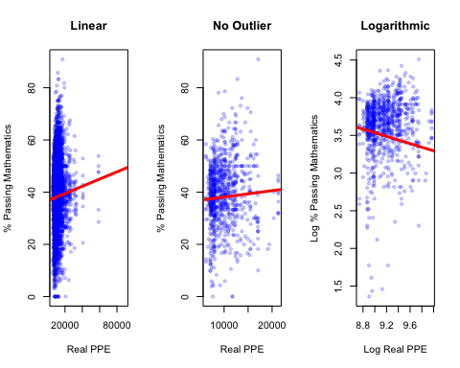

detach()